

Currency Trading News Alert System  
Interim Report

Word Count: 1095

Higher Diploma in Science in Computing

(Software Development)

Gordon Leary (10352606)

10352606@mydbsi.ie

09/07/2018

Acknowledgements:

# Contents

Contents 1

1. Introduction 2

Background 2

Specification & Design 2

Project Testing and Evaluation 2

Demonstration of Progress 2

Future Work 2

Appendices 2

2. Project Scope and Objectives 2

3. Learning Objectives 3

4. Technical Specification of the Project 3

5. Project Plan 5

6. Conclusion 6

7. References / Bibliography 6

Appendix 1 – Design specification: 7

Appendix 2 – Sample XML code: 7

# Introduction

Aims / Scope / approach / assumptions

Currency traders take positions in the market with a view to making a profit by buying a currency pair at a given price and then later selling it at a higher price, the reverse, ‘shorting’, is also possible.

Each week economic data is announced at specific, scheduled times. Most dealing brokerages publicise the times of these news events at the beginning of each week, and then the results as they are released.

These news announcements have the potential to move the market significantly against the position held by traders, causing larger than expected losses. Many shorter-term traders stay out of the market completely at these times, deliberately avoiding any possible negative volatility.

Although there are many tools to automate the trading process, many short-term traders who open and close multiples trades in the same day, often do so manually, keeping note of any news announcements and exiting their trades beforehand.

I propose to develop a mobile phone application to help the trader with this process.

Approach:

I am using an Agile type approach, aiming to keep the scope of the project small and tight, working towards my goals and objectives, expanding on this, time permitting, from a list of options in the future work section.

I am doing regular backups and commits of all code and documents to GitHub. I am also doing a lot of research on Xamarin development, using tutorials on Microsoft’s MSDN channel, using these to develop small proof of concept apps, which I then integrate into the main project.

# Background

the context of the project;

the anticipated benefits of the system;

typical users of the project product;

any theory associated with the project;

the software development methods used;

any relevant/similar existing software/hardware

# Specification & Design

The Specification and Design section should give the reader a clear picture of the system to be developed and why it is being developed it in a particular way rather than in another way.

In brief:

Specification: To inform the reader what the software system is required to do.

Design: The top-level details of how the software meets the specification.

Extensive use of diagrams, such as entity-relationship and UML diagrams will be included in this section to elaborate the design

# Project Testing and Evaluation

* Manual testing for UI elements (collect data & enter into Excel spreadsheet)
* I would prefer to be using test driven development, TDD, but would need to implement the system using MVC to achieve this, a possible consideration for future work.
* Unit tests for non-UI code, e.g. filtering of xml data in the view all currency events section.

# Demonstration of Progress

* Code listing of the application to date (appendix).
* Log of all work done.
* Accompanying Visual Studio code zip file.

# Future Work

* Integrate application with Google Calendar.
* Automatically check to see if new xml date is available for download.
* Verify downloaded xml files are valid.
* Landscape and portrait modes for different devices.
* Localisation – convert the app to another language, e.g. French.
* Import, export .csv file of ‘watch-list’ events.
* Convert application to a Model, View, Controller type structure to enable enhanced testing of the application.

# Project Plan

Milestones Achieved:

* Small proof of concept app – to demonstrate a working example of calling an alarm or notification at a pre-scheduled time, e.g. setting mobile phone to ring, vibrate and display an on-screen message at a set time. (1 week)
* Console app to demonstrate retrieval and manipulation of the 3rd party XML news event list, e.g. convert XML data to list & sort by currency, date or impact (NOT stored in database – yet). (2 weeks)
* A non-functional mock-up / prototype to;
* display design and flow of app from one screen to another,
* use of menus, graphics and theme templates,
* hard-coded sample data. (2 weeks)
* Commence adding functionality to prototype:
* Prototype produced with basic functionality.

**Milestones to be achieved:**

* Update weekly XML data section;
* Import xml file or download from URL which is stored in Shared-Preferences, update & verify. (1 week)
* Display all content from XML in list;
* Refine by user selected buttons for currency, market impact, date.
* Add user selection to a watch list, store in database, display. (2 weeks)
* Create device alarms & notifications from watchlist;
* Alarms - add, view, delete, reset all.
* Set ‘alarm prior to announcement’ amount.
* Export watchlist to CSV file & selected email address. (2 weeks)

**Revised Milestones to be achieved:**

* Wire-up DatePicker & TimePicker ‘proof of concept’ app into Personal Alerts.
* List of Personal alerts (watch-list):

Display WatchList

Add Personal Alert

Edit / Delete Personal Alert

* Download xml file from ForexFactory vs hard coded included file (validate?)
* Display all data (formatted)
* Sorting data:
* By currency – e.g. Yen, Dollar, CAD, GBP (need currency icons)
* By impact – high, medium, low
* By both, in any combination – checkbox menu, bitwise example C# book
* Add onItemClick() event to currency announcements – to add alert to an item (add it to watch list)
* SQL-PCL:
  + - Research 🡪 Proof of concept app 🡪Integrate into app.
    - On app start, in SpashActivity -Load data from SQL-PCL database.
    - On app close, write out, save, data to SQL-PCL database.
* ReCycler View:
  + - Research 🡪 Proof of concept app 🡪Integrate into app.
* Theme & UI polishing / refinement
  + - Test on different emulated phones (set up other emulators).

Following an Agile-type methodology, producing a prototype, has helped to clarify my approach, especially the layout and design of the app.

# References / Bibliography

Deitel, Deital, 2014. *Visual C# 2012 How to Program* 5th ed.  H. Marcia et al., eds., Harlow: Pearson Education.

Leibowitz, M., 2015. *Xamarin Mobile Development for Android Cookbook* 1st ed. A. Banerjee et al, eds. Birmingham: Packt Publishing Ltd.

Albahari, Albahari, 2016. *C# 6.0 Pocket Reference* 1st ed. B MacDonald et al., eds., California: O’Reilly Media Inc.

Sommerville, I., 2015. *Software Engineering* 10th ed. H. Marcia et al., eds., Harlow: Pearson Education.

Xamarin University. Available at: <https://university.xamarin.com> [Accessed May 2018].

Xamarin Android Tutorials by Joe Rock. Available at: <https://www.youtube.com/channel/UCFH-Tn6ggt9yLWJ4V9NizZA> [Accessed May 2018].

C# Training Tutorials. Available at :<https://www.youtube.com/user/IAmTimCorey> [Accessed May 2018].

Xamarin Documentation: Available at: <https://docs.microsoft.com/en-us/xamarin/#pivot=platforms&panel=Android> [Accessed May 2018].

# 

# Appendices

(?include user manual in appendix)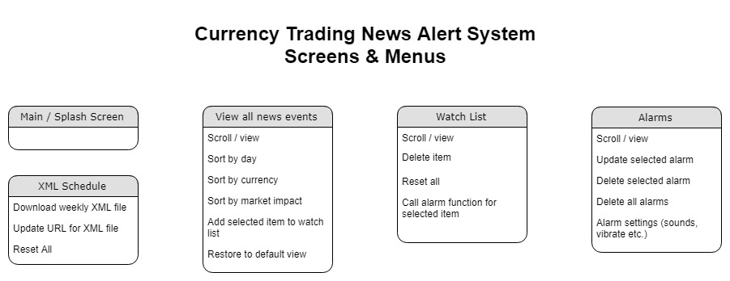Appendix 1 – Design specification:

Class Diagram:

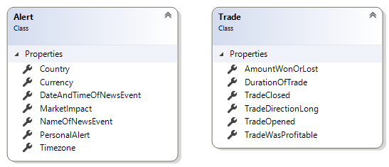

WatchList: (list of alert objects)

TradeReportList: (list of trade objects)

# Technical Specification of the Project

I propose to develop a mobile application using the following tools & technologies;

Xamarin.Android

Visual Studio 2017 (for development & unit testing)

C#

LINQ to XML

SQLite-PCL

GitHub

# Appendix 2 – Sample XML code:

Sample XML of fundamental news releases published weekly. Available at: https://www.forexfactory.com/ffcal_week_this.xml

<?xml version="1.0" encoding="windows-1252"?>

<weeklyevents>

<event>

<title>FPI m/m</title>

<country>NZD</country>

<date><![CDATA[04-15-2018]]></date>

<time><![CDATA[10:45pm]]></time>

<impact><![CDATA[Low]]></impact>

<forecast />

<previous><![CDATA[-0.5%]]></previous>

</event>

<event>

<title>Rightmove HPI m/m</title>

<country>GBP</country>

<date><![CDATA[04-15-2018]]></date>

<time><![CDATA[11:01pm]]></time>

<impact><![CDATA[Low]]></impact>

<forecast />

<previous><![CDATA[1.5%]]></previous>

</event>

<event>

<title>WPI m/m</title>

<country>EUR</country>

<date><![CDATA[04-16-2018]]></date>

<time><![CDATA[5:52am]]></time>

<impact><![CDATA[Low]]></impact>

<forecast><![CDATA[0.4%]]></forecast>

<previous><![CDATA[-0.3%]]></previous>

</event>

</weeklyevents>

# Project Scope and Objectives

Minimum Viable Product:

* To download a list of all available scheduled news events for the current week from a third-party website (sample xml file included in appendix 2).
* To be able to sort this list by both currency and expected impact on the market.
* To let the user, select items of interest from the above and store them in a watch list.
* To set alarms and notifications on the user’s mobile device based on their watch list, to alert them of an imminent news announcement release.
* User can add personal alerts to the watch list to be alerted at times not in the XML schedule.
* User can select amount of time to be notified before the news announcement, e.g. 10 or 15 minutes before the news release.

**Questions for Dhoot:**

Database access – write to db constantly OR load / save to DB on app start & close.

‘Static’ chat.

Minutes of our meetings.

Check: Does laptop sleep mode effect running on Samsung phone as it does the emulator?